**Summary:- Below are the steps take 1 by 1 to solve this business problem**

1. **Importing**:- Started off with importing the dataset provided from a CSV file
2. **Reading the Data:** After Importing reading the data and data dictionary provided is necessary as to know what variable and data we are dealing with
3. **Data Cleansing and Data Manipulation: -** Cleaning the redundant, duplicate data. Also there were ‘select’ values as people had not chosen any option for that column or their option was not present, so we replaced that with NA and then imputed them with maximum occurrences for that column. We also removed column having more than 40% null values.
4. **Exploratory Data Analysis**: - Once we are done with all the data cleaning tasks, we move to EDA. Here we did Univariate, Multivariate Analysis of all the variable and compared it against the target variable ‘Converted’ and drawn inference from them. During that we saw outlier being present and model being sensitive to outlier, we used outlier capping to get rid of them.
5. **Data Preparation: -** Data preparation involved converting the ‘YES’ & ‘NO’ response variable to Binary variable and Dummy variable creation for the categorical columns while dropping the redundant columns. Then we divided the data in Train Set and Test Set data and finally we scaled the data using Standard scalar before moving to the model building process.
6. **Model Building: -** The First model we build was using all the dummy variable and saw very high P-value and many variables were not contributing to the model build. Then we used Recursive Feature Elimination (rfe) to build the model again. This process continued till we have the P-Values below 0.05 and VIF for all the variable below 5 for the build and we took that as the Final Model.
7. **Prediction: -** After Model building we did the prediction on the Test Data
8. **Model Evaluation: -** Model Evaluation is done by checking the Accuracy, Sensitivity and specificity of the Model. We got decent values 87%, 73% & 97% respectively for our model.
9. **Optimal Cut-off (ROC Curve): -** The ROC Curve should be a value close to 1. We are getting value of 0.93 indicating a good predictive model.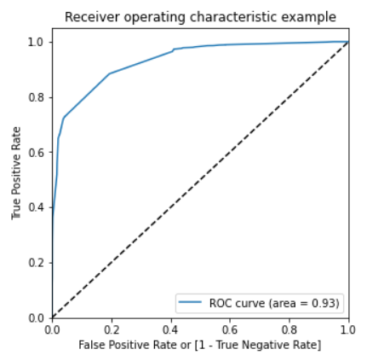
10. **Precision and Recall:-**

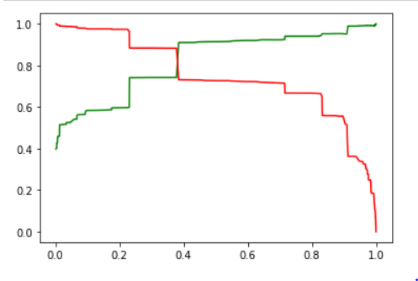

1. **Making Prediction on test data:-**  Finally we made prediction using the Model Build and below are the results
2. **Accuracy: 85.4%**
3. **Sensitivity: 70%**
4. **Specificity: 94.2%**